Symmetric and asymmetric encryption
IGCSE Computer Science 0478 | 2.3 Encryption | Student booklet
Name: _______________________________ | Date: _____________

Do Task 1 from memory. Learn from the examples and discuss the checks before exam practice. Numbered task wording matches the worksheet exactly; the teacher has a separate key.
Task 1 Recall: data transmission [12 marks]
Original closed-book retrieval from 2.1 Packet switching. Suggested marks. Use (a)–(c) if time is short.
(a) Name the three parts of a packet. [3]

(b) Name three items found in a packet header. [3]

(c) Describe how a router decides where to send a packet next. [2]

(d) Explain how packets arriving out of order can be reassembled. [2]

(e) What does a checksum help detect? Does it prevent other people reading the data? [2]

Learn Why encrypt?
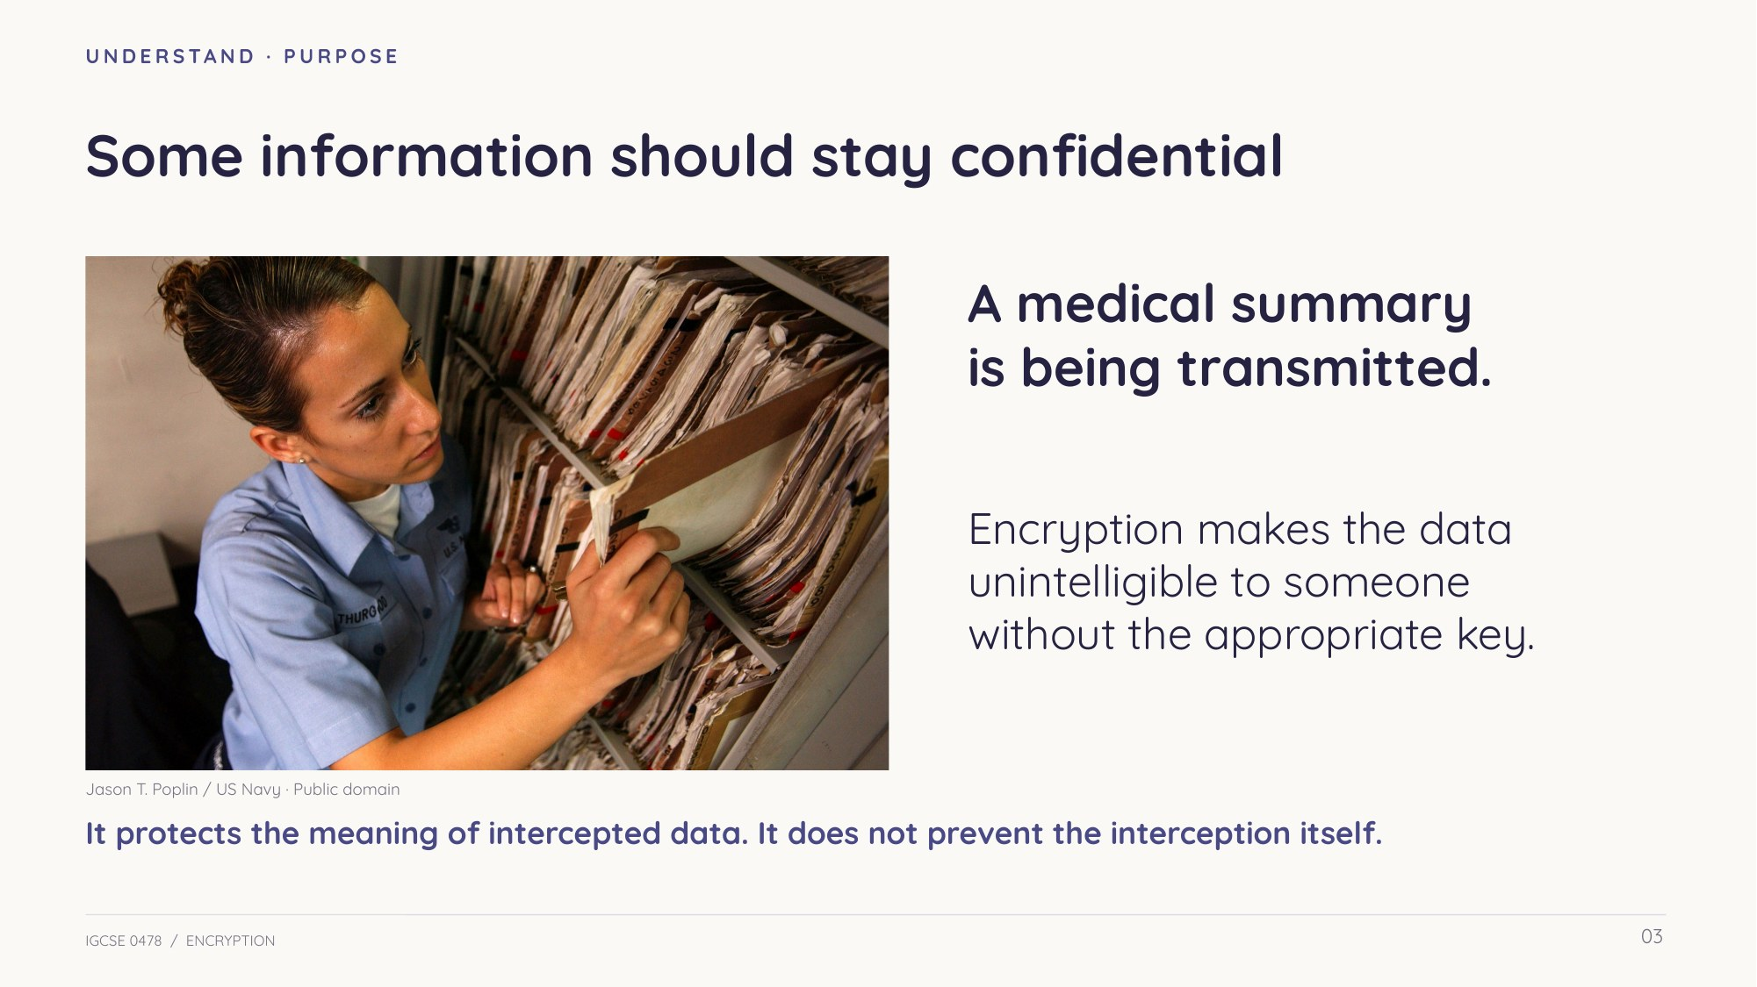
Slide 3 — Confidential information
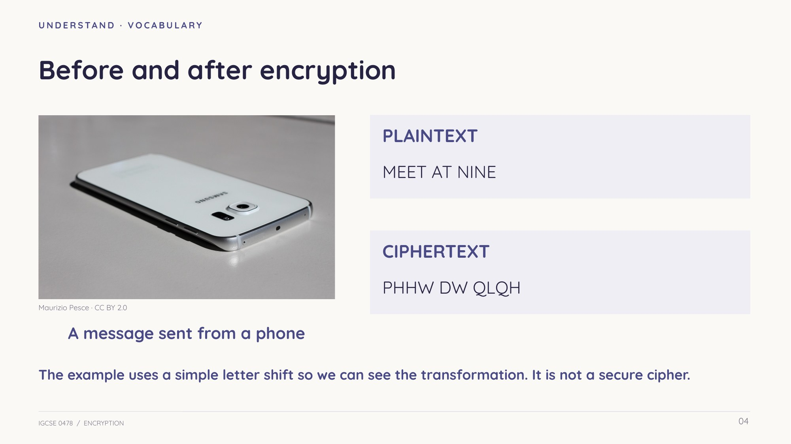
Slide 4 — Plaintext and ciphertext
Learn A method and a value
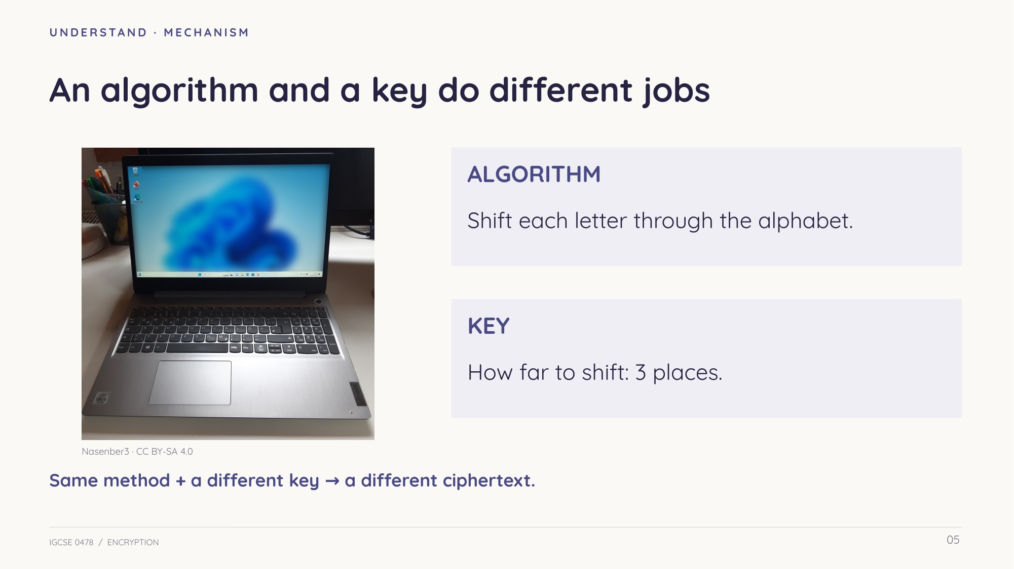
Slide 5 — Algorithm versus key
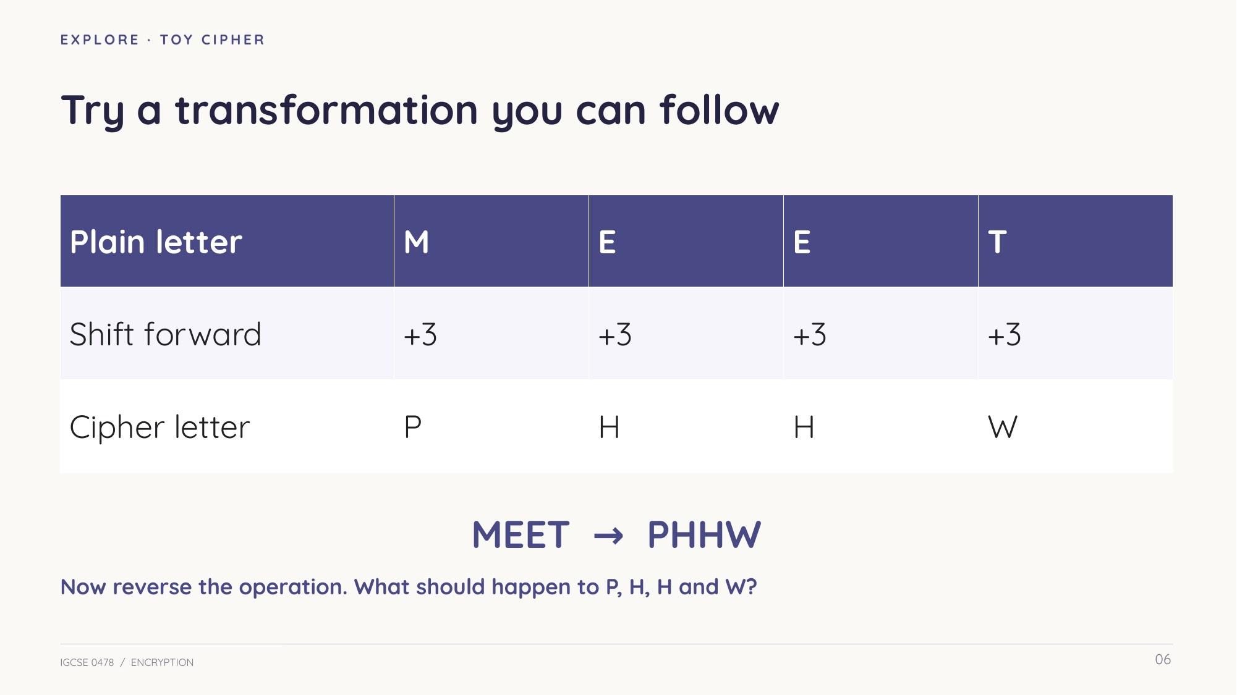
Slide 6 — Worked letter-shift illustration
Learn Symmetric encryption
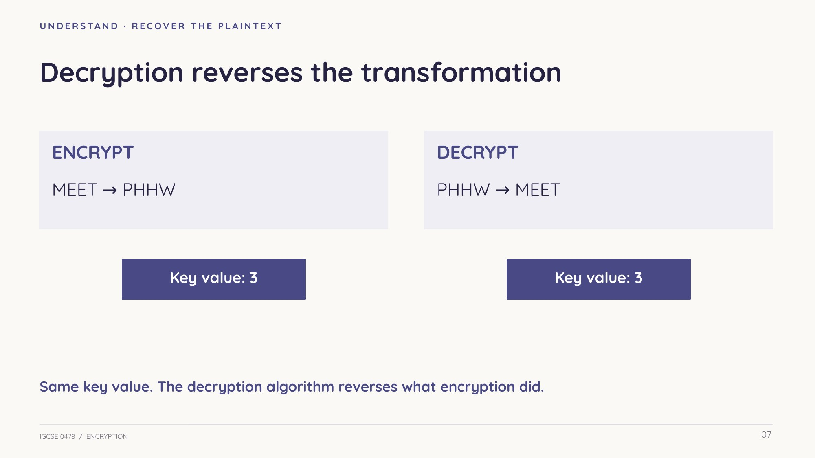
Slide 7 — Reverse the operation using the same key value
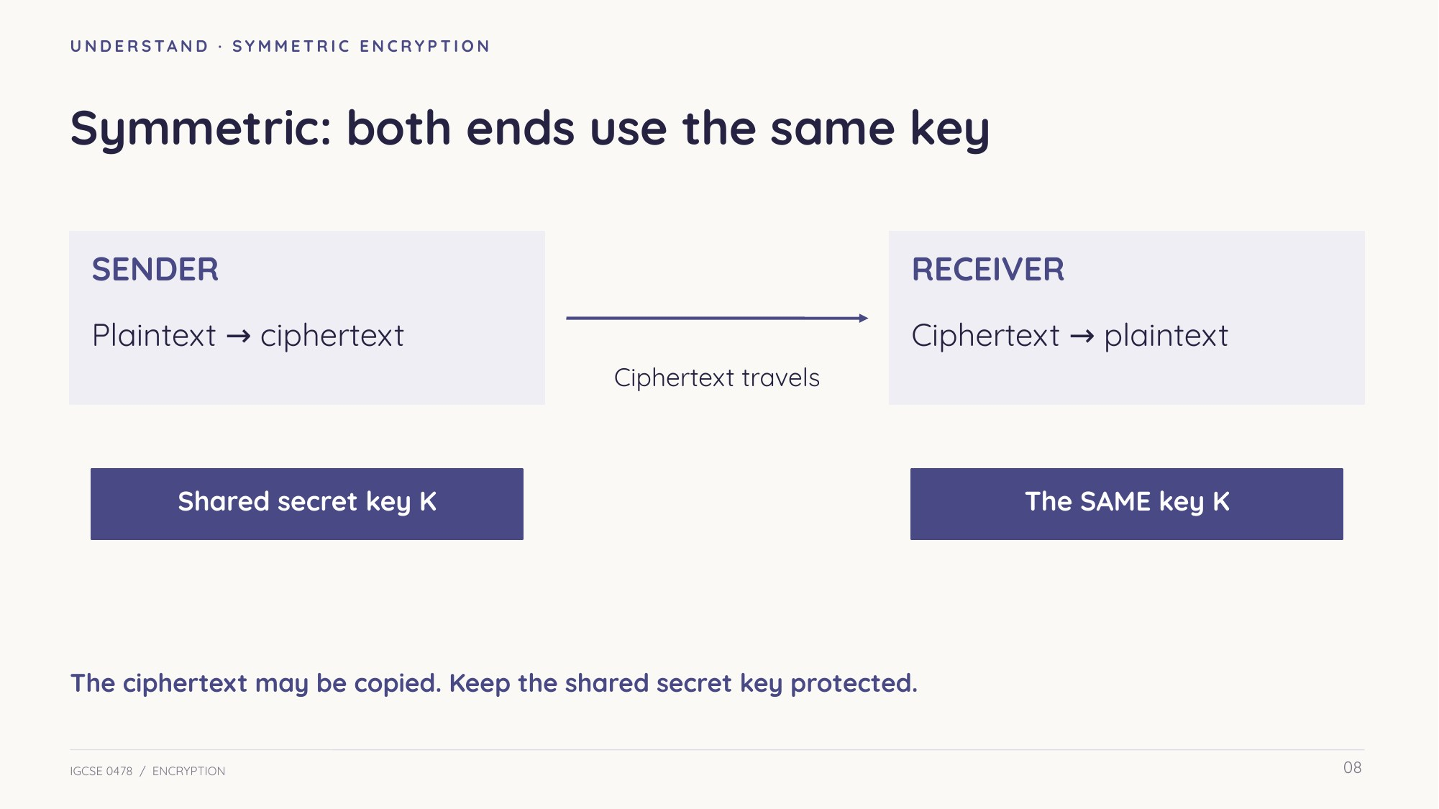
Slide 8 — Both ends use the same secret key
Learn Interception and shared secrets
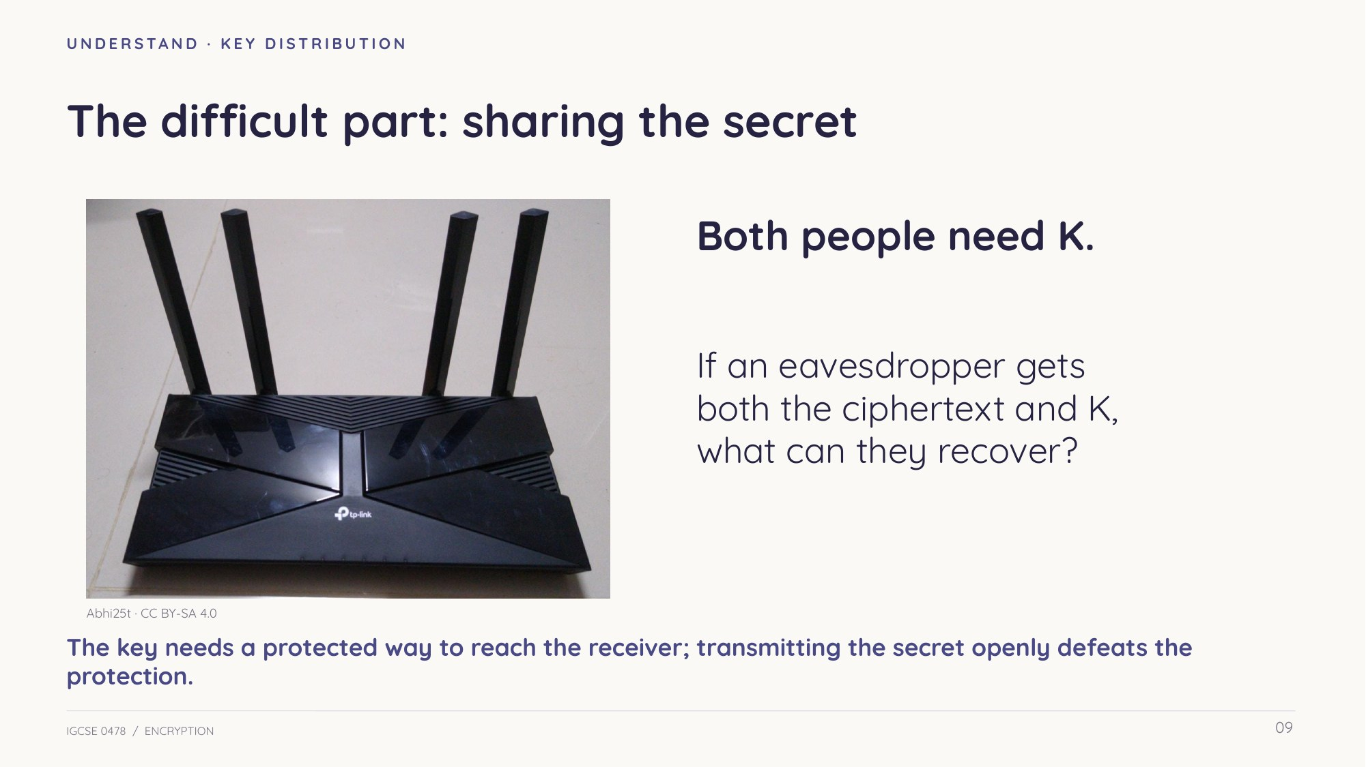
Slide 9 — The key needs protected distribution
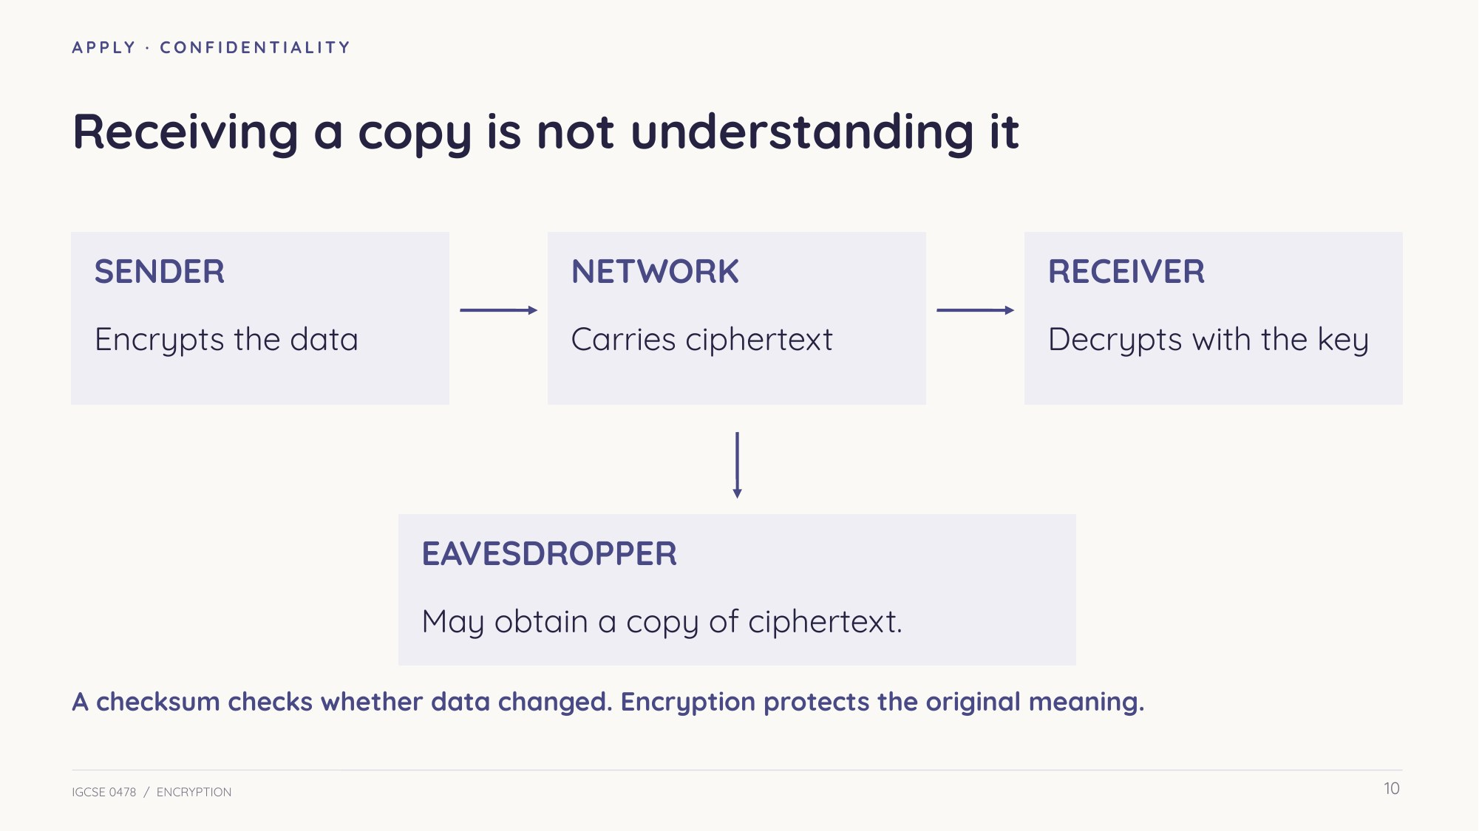
Slide 10 — A copy of ciphertext is not the original meaning
Learn Public and private keys
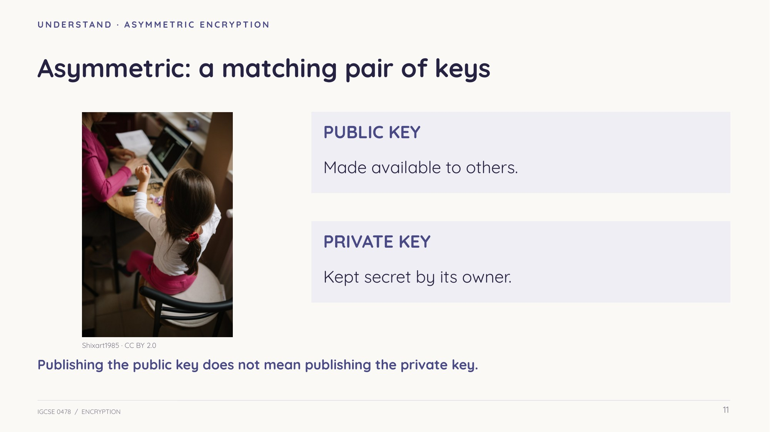
Slide 11 — A matching pair
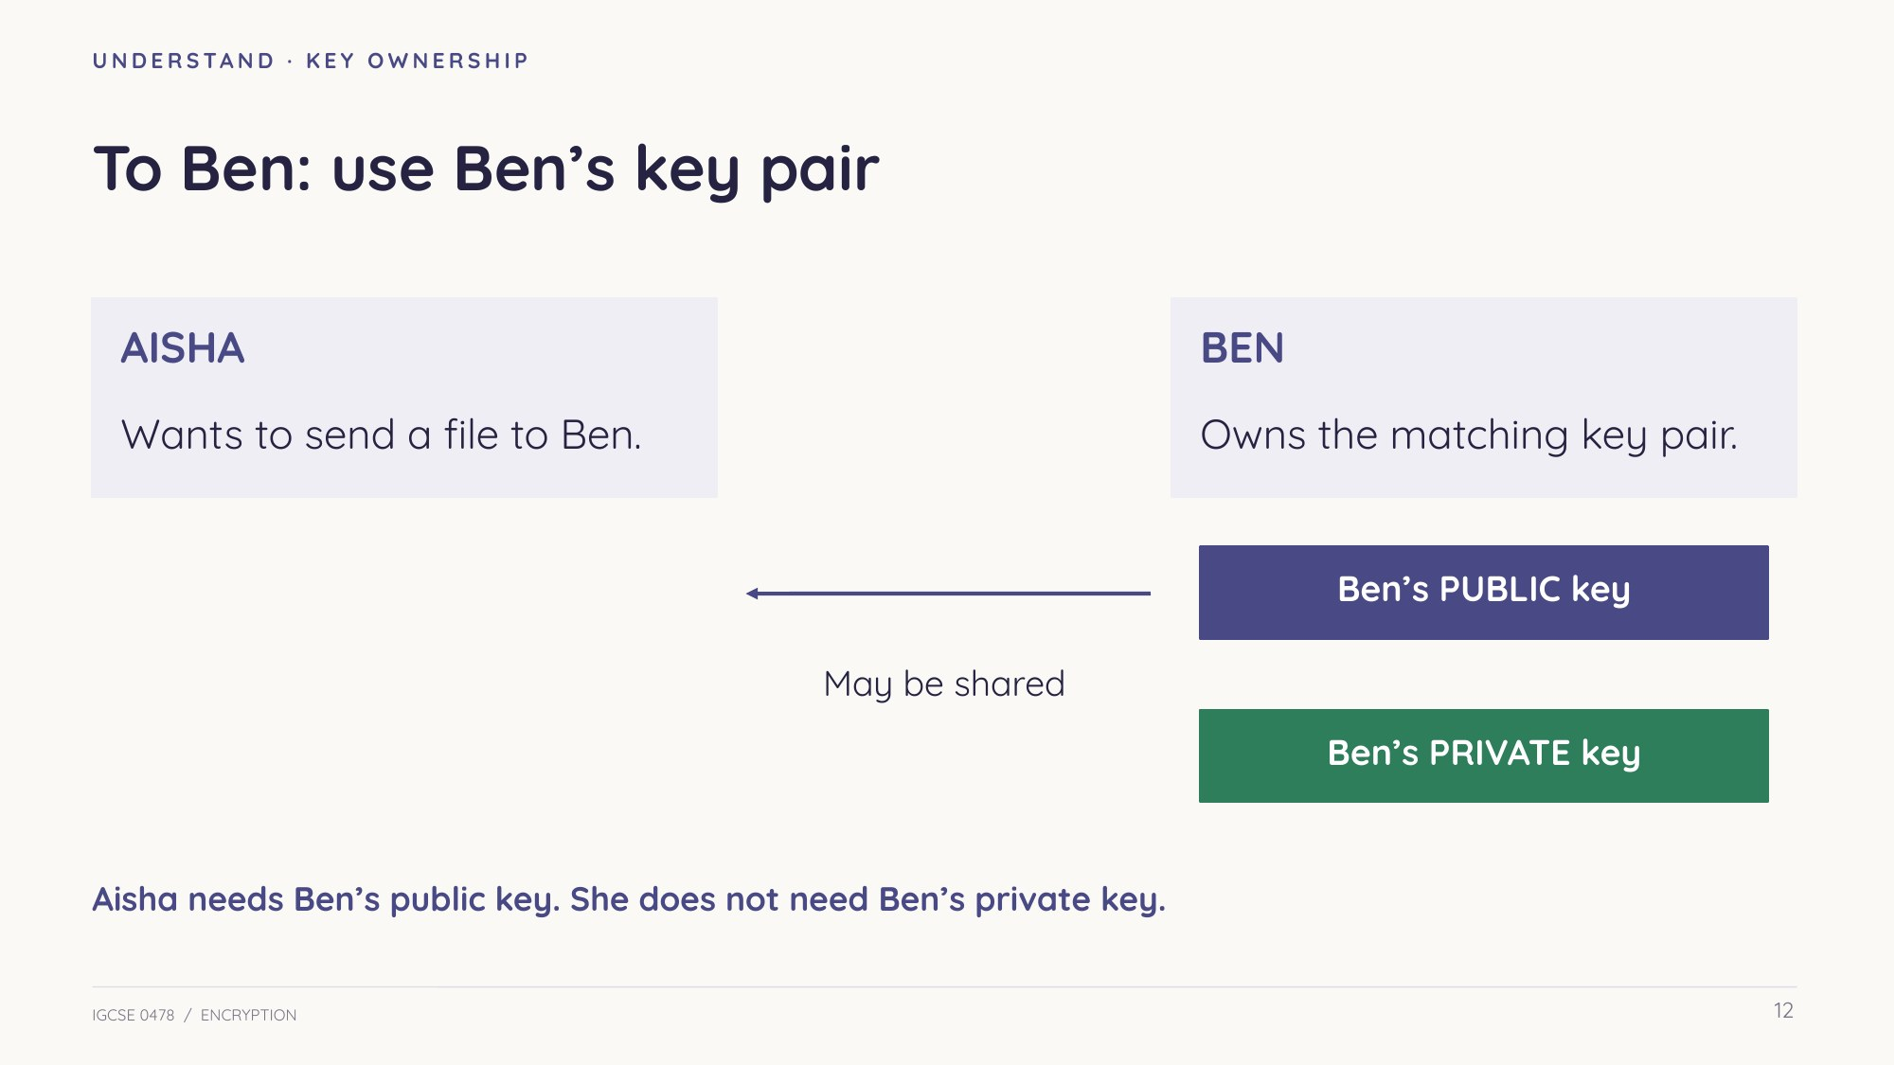
Slide 12 — Keys belong to the recipient
Learn Send and reply
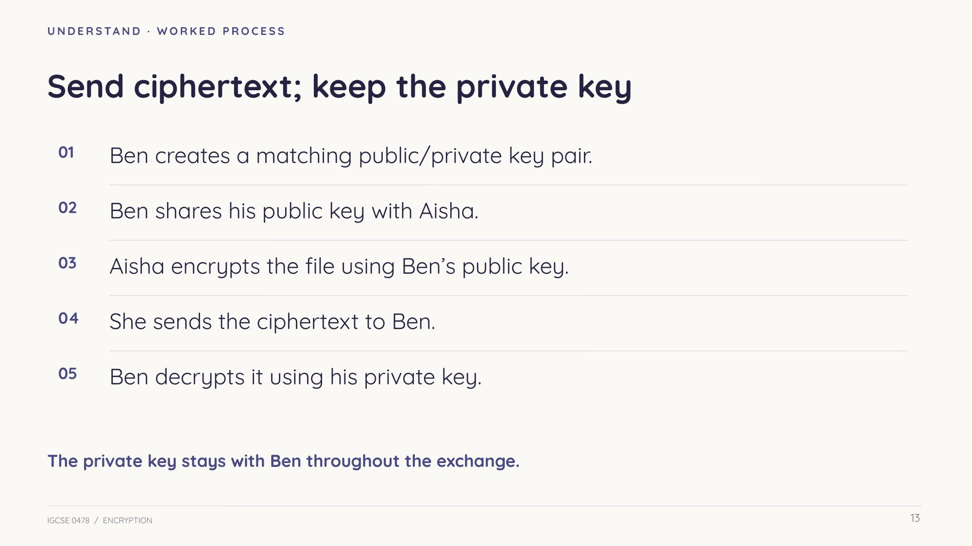
Slide 13 — Aisha sends to Ben
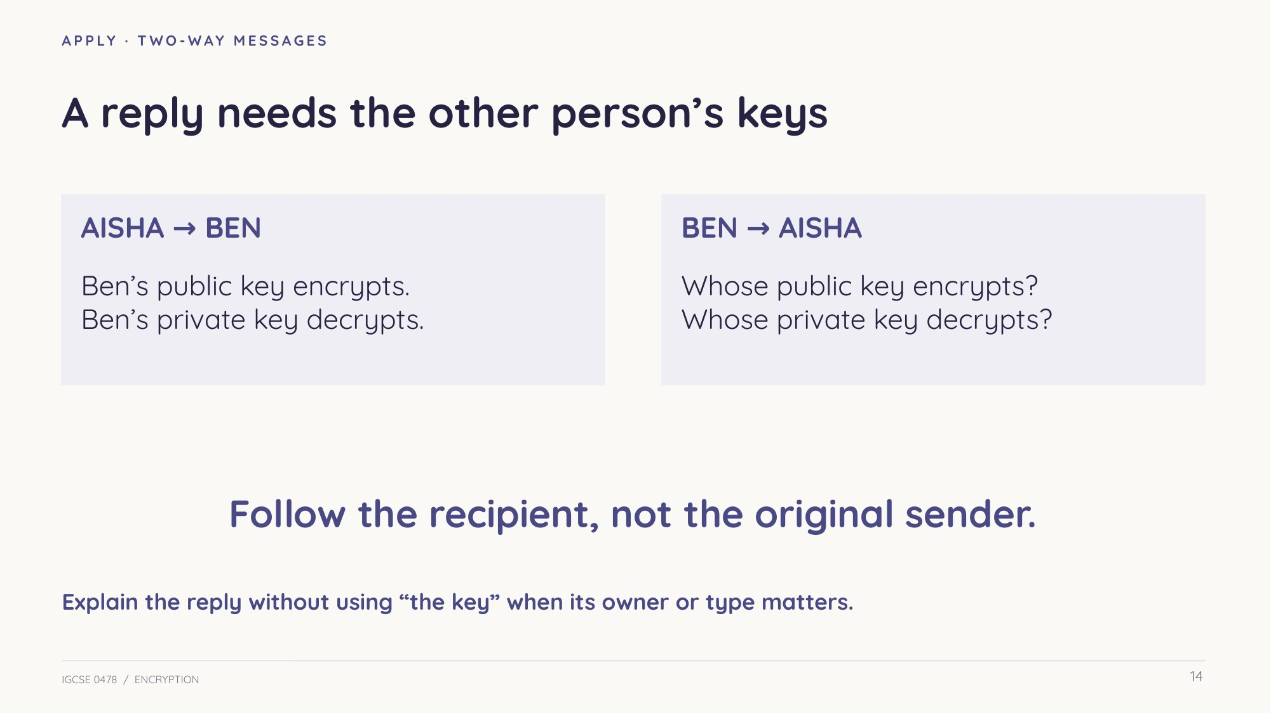
Slide 14 — Use the other recipient’s pair for a reply
Check understanding Before practice
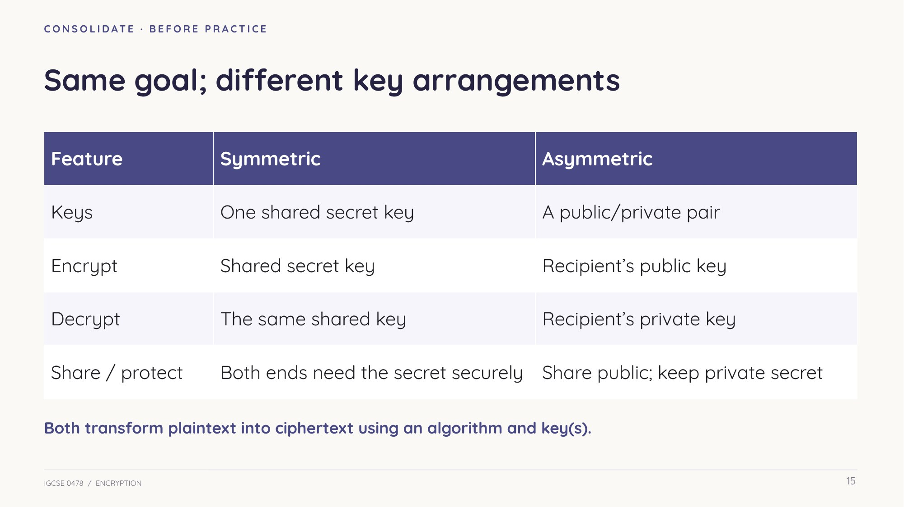
Slide 15 — Different key arrangements
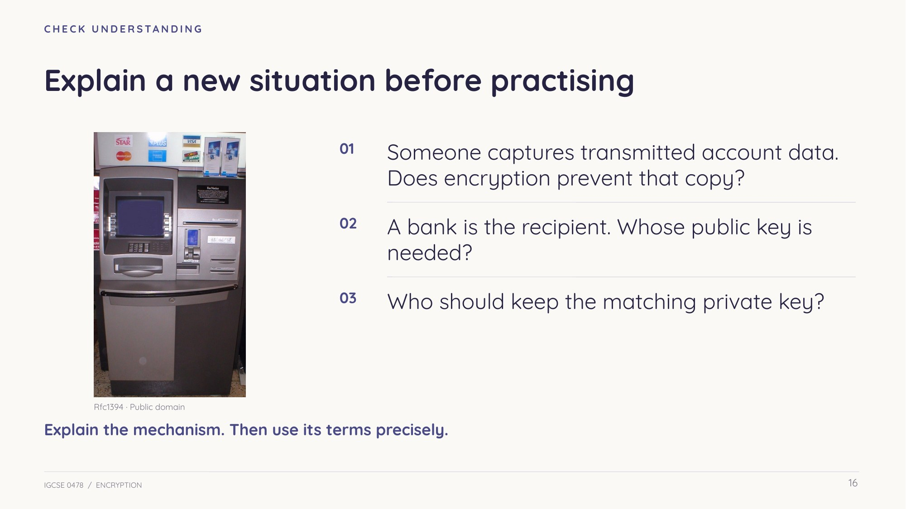
Slide 16 — Explain a new confidential transmission
Practice Use the mechanism precisely
Read the question, name the correct key type and owner, and explain the relevant transformation. Attempt independently before feedback. Matching model-answer slides are omitted here.
Task 2 Meaning and purpose [5 marks]
Parts (a) and (c) are original with suggested marks; (b) retains its published allocation.
(a) Define plaintext and ciphertext. [2]

(b) State the purpose of encrypting data before it is transmitted. [1]
0478/12 Feb/Mar 2024 Q7(a)(i) — adapted

(c) Explain why an encrypted message may still be intercepted without revealing the original information. [2]

Task 3 Symmetric encryption [8 marks]
Part (a) retains its published allocation. Part (b) is an original illustration, not a secure cipher.
(a) Explain how data is encrypted using symmetric encryption. [4]
0478/12 May/June 2024 Q2(c)(i) — adapted

(b) Use a letter-shift algorithm with key value 4. Preserve spaces and wrap after Z. The decryption operation reverses the shift. [4]
(i) Encrypt BRING MAP. One mark for each correctly encrypted word. [2]

(ii) Decrypt XLMW. [1]

(iii) State the key value used for decryption, and explain why it is still symmetric. [1]

Task 4 Public and private keys [10 marks]
Part (a) is adapted from a real four-mark question. Part (b) is original, with six suggested marks.
(a) Complete the asymmetric-encryption description using the word bank. Use each term at most once. [4]
0478/11 May/June 2024 Q7 — adapted
Word bank: plaintext, ciphertext, public key, private key, certificate, symmetric, protected.
A: __________________ becomes B: __________________ using C: __________________. The receiver recovers the original data using D: __________________.
(b) Maya sends a confidential file to Leo using asymmetric encryption. Leo generates a matching key pair. Complete the table. One mark for each correct owner/type cell. [4]
Operation | Key owner | Key type
Maya encrypts the file | ________________ | ________________
Leo decrypts the file | ________________ | ________________
Which one of Leo’s keys may he make available to Maya and other senders? [1]

Does Maya need Leo’s private key to send him the encrypted file? Explain your answer. [1]

Task 5 Compare and choose [8 marks]
All parts retain published Cambridge allocations. Attempt independently before model answers.
(a) Describe the differences between symmetric and asymmetric encryption. [4]
0478/12 Feb/Mar 2024 Q7(a)(ii) — adapted

(b) Give one similarity between symmetric and asymmetric encryption. [1]
0478/13 Oct/Nov 2024 Q2(g)(ii) — adapted

(c) Give one reason to use asymmetric encryption instead of symmetric encryption. [1]
0478/11 May/June 2025 Q6(b) — adapted

(d) Select ONE correct statement about symmetric encryption: A Encrypted data is plaintext; B It is always the most secure method; C The key is shared with the receiving device; D It uses two different keys. [1]
0478/11 Oct/Nov 2025 Q2(e)(i) — adapted

(e) Name one other type of encryption that could be used instead of symmetric encryption. [1]
0478/11 Oct/Nov 2025 Q2(e)(ii) — adapted

Task 6 Repair the explanation [8 marks]
Original follow-up practice. For each claim, identify the error and correct it. Two suggested marks per claim.
(a) Encryption stops someone intercepting the transmitted data. [2]

(b) Symmetric encryption needs a different secret key for decryption. [2]

(c) Maya should encrypt a confidential message for Leo using Maya’s public key. [2]

(d) Anyone with Leo’s public key can decrypt the confidential message encrypted for him. [2]

Review Explain the reply
Sam sends a confidential file to Priya. Which key encrypts it? Which key decrypts it, and who keeps that key? Would encryption stop somebody copying the transmitted data?

Priya now replies to Sam. Explain which key pair is used, and who keeps the private key.

Sources and photograph credits
Core source: teacher-supplied Hodder extract, printed pp.63–66, and Cambridge 0478 section 2.3. Eight practice parts are adapted from published 2024–2025 questions; 17 official marks retained. Original activities use suggested marks. The textbook quantum extension is outside this core lesson.
Photographs show representative devices/settings. No claim is made about the pictured devices’ specific cryptography. Photos resized/recompressed with aspect-preserving crops in some slide placements; no subject alterations.
CAFE — Larry D. Moore — CC BY 4.0
Photograph source · Licence terms
MEDICAL — U.S. Navy photo by Photographer's Mate 3rd Class Jason T. Poplin — Public domain
Photograph source · Licence terms
PHONE — Maurizio Pesce from Milan, Italia — CC BY 2.0
Photograph source · Licence terms
ROUTER — Abhi25t — CC BY-SA 4.0
Photograph source · Licence terms
LAPTOP — Nasenber3 — CC BY-SA 4.0
Photograph source · Licence terms
ATM — Rfc1394 at English Wikipedia Later versions were uploaded by Awyong Jeffrey Mordecai Salleh at en.wikipedia . — Public domain
Photograph source · Licence terms
REMOTE — Shixart1985 — CC BY 2.0
Photograph source · Licence terms
Question-by-question sources and marking notes: Encryption_Exam_Coverage.md in this lesson’s repository folder.

